CHAPTER 1
INTRODUCTION

1.1 OVERVIEW OF TIME TRACKING AND MANGEMENT

Information technology playing an increasing role in the economy, companies have grown more heavily dependent on the successful delivery of information systems (IS). However, many software projects result in systems that do not function as intended, or even those that never delivered. As organizations continue to invest time and resources into strategically important software projects, monitoring and controlling the risk associated with such projects becomes a critical concern. In a software project, plans are usually drawn to ensure that work is carried out to the desired progress, which highlights the importance of tracking and control in software projects. Therefore, progress on the project is required to be monitored and compared as the work proceeds in order to be able to identify and measure these differences. Mechanisms of project monitoring and control are essential for successful project delivery, as they provide an understanding of the project’s progress so that appropriate corrective actions can be taken when the project’s performance deviates significantly from the plan. A project’s documented plan is the basis for monitoring activities, communicating status, and taking corrective actions. Progress is primarily determined through the comparison of the actual work product, task attributes, effort, cost and schedules to predefined plans at prescribed milestones or control levels within the project schedule or work breakdown structure (WBS). Since progress monitoring typically includes periodically measuring actual completion of activities and milestones, comparing actual outputs against the schedule documented in the project plan, and identifying significant deviations from the estimated project plan schedule,
project members are required to periodically fill in progress reports. Meanwhile, the project manager must regularly review each project member’s progress, performance, and results to identify and document significant issues and deviations from the plan. Most of the existing project management and control
(PMC) systems evaluate the differences between the planned progress and work progression by quantitative data analysis, such as earned value management.

1.2 PROBLEM STATEMENT
Monitoring and control are two important issues in project management. Many efforts have been made by researchers to improve these areas. The intuitive approach of project monitoring and control is to collect factual data such as the task plan, the percentage complete, and quality of work in terms of monitoring to measure actual values of the project. Comparing this data with planned values indicates whether the project is meeting the targets of the work plan.

1.3 OBJECTIVE OF THE PROJECT

Time Management System (TMS) tracks and manages the time spent by resources on various projects activities categorized by time codes. Timesheet application collects the time records from time tracking change management systems and manage them as time sheets.
1.4 SCOPE OF THE PROJECT
Time management broadly includes, Time Sheet life cycle management (new, submitting, revoking, approval and rejection)
- Generating appropriate reports on time spent details
- Access your timesheets at any time, regardless of the place and the device you use. All you need is an Internet connection.
- TIMETRACKER allows your employees to record their working hours, either manually or with our timer.

CHAPTER 2
LITERATURE REVIEW

2.1 WORK TIME MANAGEMENT IN A SMALL COMPANY AS EXAMPLE OF USAGE THE WEB TECHNOLOGIES

"Work time management - WTM" is an application presenting an example of usage popular and open Web technologies accessible on the Internet. Web technologies used in the application are divided in two main groups. The architecture of the WTM application is based on the MVC design pattern (model, view, controller), which provides a division of the project on a layer of view, layer of view and layer of controller. Such a division supports ease of further modification and improvement of functionality. The whole creates the application designed to collect the information of working time about individual employees, tasks given to them, and how much time they are working on single task. All of this provides the basic information to the employer about the worker productivity and can be helpful to calculate the amount of salary due to be paid employee.

2.2 FRAMEWORK OF DISPUTE AVOIDANCE AND RESOLUTION OF CONSTRUCTION PROJECT MANAGEMENT
Construction project management is full of risks where construction industry witnesses disputes and claims in every one construction project since claims and disputes are popular in construction industry. When steady development of Chinese economics keeps on astonishing the world, many international contractors are sharing opportunities of construction projects while others are struggling against tedious disputes in projects. Chinese culture and governance also affects construction management pattern and negotiation tactics in projects. Construction professionals need more knowledge and skills to manage and resolve conflict and disputes efficient and effectively, and the project progress and quality of the product will be improved. This paper reveals an effective approach to avoid and resolve construction disputes in construction project management. At the same time, this paper describes an effective dispute resolution mechanics combined with third-party and local authorities. Although dispute administration is not the ultimate or compulsory process in resolving the construction dispute, the administration framework might affect construction project management and dispute administration is a unique and effective option in project management market.

2.3 .OPTIMIZATION OF SHEET FLANGING FORMING BASED ON KRIGING METAMODEL
Meta models based on responses from designed (numerical) experiments may form efficient approximations to functions in engineering analysis. They can improve the efficiency of engineering optimization substantially by uncoupling computationally expensive analysis models and (iterative) optimization procedures. This paper investigated the kriging meta model approach. In order to prove accuracy and efficiency of Kriging method, the nonlinear functions as test functions are implemented. At the same time, the practical nonlinear engineering problems such as sheet flanging forming are also optimized successfully by proposed method. The results prove Kriging model is an effective method for nonlinear engineering problem in practice.

2.4 .BIG DATA REAL-TIME PROCESSING BASED ON STORM
As the growth of Internet, Cloud Computing, Mobile Network and Internet of Things is increasing rapidly, Big Data is becoming a hot-spot in recent years. Big Data Processing is involved in our daily life such as mobile devices, RFID and wireless sensors, which aims at dealing with billions of users' interactive data. At the same time, real-time processing is eagerly needed in integrated system. In this paper, several technologies associated with real-time big data processing are introduced, among which the core technology called Storm is emphasized. An entire system is built based on Storm, associated with RabbitMQ, NoSQL and JSP. To ensure the practical applicability and high efficiency, a simulation system is established and shows acceptable performance in various expressions using data sheet and Ganglia. It is proved that the big data real-time processing based on Storm can be widely used in various computing environment.

2.5 BALANCE SHEET CHANNEL OF MONETARY POLICY TRANSMISSION
Using balance sheet data for a panel of Chinese Listed firms, we try to find evidence of the balance sheet channel of monetary policy transmission. The results indicate that the quality of firms' balance sheet during the tighten period is worse than the quality during the loose period, and the effect of changes in monetary policy on the quality of firms' balance sheet is asymmetric over time. In periods of tight monetary conditions, M1 has significant positive correlation with the interest bear ratio, while the correlation is not significant during loose periods. The results also suggest that the balance sheet channel of monetary policy transmission is not subject to the nature of corporate, while have significant positive correlation with ownership concentration. Small firms bear most of the reductions, they suffer more from monetary tightening than big firms.

2.6 ANALYTICAL EXPENSE MANAGEMENT SYSTEM
Although the development of communication technologies (e.g: UMTS, ADSL) allowed the elaboration of multiple users' Web applications (e.g. information storage), there are still many improvements on many applications to be done and uncovered areas. Expense management systems on Web application area are still in their infancy. Expense management software is widely spread in companies and most of time supported by their intranet. These solutions are quite simple as they mainly collect the information related to the expenses and may propose a simple aggregation of these figures. The result is close to what an excel sheet provides.

2.7 TASK SCHEDULING FOR TIME-TARGETED WORKFLOW EXECUTION ON CLOUD
With increasing demand of data-intensive applications, a workflow with multiple distributed parallel applications becomes a useful way to build various large scale data processing applications on cloud environments. However, previous scheduling approaches for executing workflows are focused on estimating minimum make span of executions on pre-configured clusters. In this paper, we present two time-targeted selective task scheduling schemes which consider malleability and rigidity of each task, named SDER (Sequential Deployment with Expanded Resources) and DDMS (Distributed Deployment on Multiple Streams). These scheduling algorithms deploy all task of workflow in sequential and distributed ways each, and estimate optimized number of resources for completing workflow execution within given deadline. We show the experimental results which compares the performance of two scheduling schemes for various workflows.
CHAPTER 3
SYSTEM ANALYSIS
3.1 EXISTING SYSTEM
The existing system Display a form to enter the number of hours spent by an employee on a task in a day like following: It should be possible to enter the time sheet either for one task at a time and one day at a time, It should be possible to enter the time for all the assigned tasks at a time, It should be possible to enter the time for all the tasks in a week at a time, It should be possible to modify the time sheets entered earlier. Once the time sheets are entered, they should be approved by their manager. Is a huge process to monitor.
3.2DISADVANTAGES OF EXISTING SYSTEM
The manual system is applied in the existing time management system s such as more manual interventions, more time consumption in case of calculations etc.,
Even though windows applications are applied in the windows application it’s harder to track the details of the work procedure of the employee.
For lager organizations the tracking is more difficult with the existing application as the complexity gets higher the risks also become higher.

3.3 PROPOSED SYSTEM
An employee timesheet is a record that you can look back on to find out how much time you spent doing something. Employee timesheets were originally developed for employers to track the number of hours worked for payroll. Employee timesheets are used to record the start and end time of tasks or simply the duration of the task. Employee timesheets may contain a detailed breakdown of tasks accomplished by the employee. Automated billing facilitates client invoicing by providing access to accurate data for all the hours worked by consulting staff. This in turn expedites the invoicing process avoiding billing backlog. In turn, payments are received much faster and the inconvenience of missed bills is eliminated. Time tracking is mainly useful for cost cutting which is done is 3 ways they are by making payroll processing more efficient, by making costs visible so you can lower them, and by automating billing & invoicing.
3.4 ADVANTAGES OF PROPOSED SYSTEM
The information can be used for project costing, job estimation, tracking, management, client billing and payroll.
Tracking time can reduce an organization's costs by making payroll processing more efficient, by making costs visible so you can lower them, and by automating billing & invoicing.
Tracking time can also increase revenue through automated billing.
Used in project management, employee timesheets improve project execution, decision-making and compliance with labor and government regulations.
The main advantage of this time sheet management is time tracking.
CHAPTER 4

SYSTEM SPECIFICATION

4.1 HARDWARE REQUIREMENTS
PROCESSOR : Intel Pentium I3
RAM : 1 GB DDR2 RAM
HARD DISK DRIVE : 250 GB
MONITOR : 20” Color LED Monitor
KEYBOARD : Multimedia Keyboard 108 Keys
MOUSE : Logitech Optical Mouse
HUB : Complex 16 lines.
BANDWIDTH : mbps.

4.2 SOFTWARE REQUIREMENTS
FRONTEND : HTML5, Bootstrap4, CSS3
BACKEND : MySQL
CLIENT SIDE SCRIPT : JavaScript
SERVER SIDE SCRIPT : PHP
SERVER : WAMP
CHAPTER 5
SOFTWARE DESCRIPTION
5.1 ABOUT SOFTWARE

5.1.1 INTRODUCTION TO PHP
PHP is a server scripting language, and a powerful tool for making dynamic and interactive Web pages.
PHP is a widely-used, free, and efficient alternative to competitors such as Microsoft's ASP.

5.1.2 FAULT TOLERANCE
The fault tolerant programming in PHP we have shown the basics of fault tolerant programming using the circuit breaker pattern.. The advantage of this approach is that it allows the querying of multiple backend services asynchronously. A timeout can be set for each of the calls and the circuit breaker will deal with failing services.
In distributed systems with PHP frontend, application talks to a number of remote services. Be it a set of services of your own, a 3rd party RESTful API or a legacy component that requires networking interaction: in complex, high-load systems occasional failure cannot be avoided.

5.1.3 INTRODUCTION TO MYSQL
MySQL is an open source relational database management system. Its name is a combination of "My", the name of co-founder Michael Widenius's daughter, and "SQL", the abbreviation for Structured Query Language.
MySQL is the most popular Open Source Relational SQL Database Management System. MySQL is one of the best RDBMS being used for developing various web-based software applications. MySQL is developed, marketed and supported by MySQL AB, which is a Swedish company. This tutorial will give you a quick start to MySQL and make you comfortable with MySQL programming.

A Relational Data Base Management System (RDBMS) is a software that −
- Enables you to implement a database with tables, columns and indexes.
- Guarantees the Referential Integrity between rows of various tables.
- Updates the indexes automatically.
- Interprets an SQL query and combines information from various tables
MySQL is a fast, easy-to-use RDBMS being used for many small and big businesses. MySQL is developed, marketed and supported by MySQL AB, which is a Swedish company. MySQL is becoming so popular because of many good reasons −
- MySQL is released under an open-source license. So you have nothing to pay to use it.
- MySQL is a very powerful program in its own right. It handles a large subset of the functionality of the most expensive and powerful database packages.
- MySQL uses a standard form of the well-known SQL data language.
- MySQL works on many operating systems and with many languages including PHP, PERL, C, C++, JAVA, etc.
- MySQL works very quickly and works well even with large data sets.
- MySQL is very friendly to PHP, the most appreciated language for web development.
- MySQL supports large databases, up to 50 million rows or more in a table. The default file size limit for a table is 4GB, but you can increase

CHAPTER 6
PROJECT DESCRIPTION
6. LIST OF MODULES
- Client module
- Project Module
- Employee Module
- Project Scheduling
- Time Tracking
- Reports

6.1 MODULES DESCRIPTION
6.1.1 Client Module:
The client details are stored in a centralized server. Each client will be allocated a unique id to track the client easily. The details of the client project information will be updated in the server. For consuming necessary time, keeping all troubles less, and to organize all documents into one place and most important , to keep track of projects that are in production for customers or for keeping an eye on errors or mistakes that occur during the work process, then a good web based management system

6.1.2 Project Module:
The project activities are portioned and the requirements are allocated to the project based on the client requirements. The budget, duration of the project activity, technology details are updated in the module. The objective for collaboration has been: getting thing done faster, cheaper and better by applying their common knowledge, bringing together a selection of resources and attainments in a project.

6.1.3 Employee Module:
The employee personal and official details are registered for project allocation based on the skillset of the employee. Each employee is allocated with specific id and it will be easier to track the employee time sheet work allotment.

6.1.4 Project Scheduling:

The project allocation is performed based on the projects and the employee availability and skillset and duration of the project. The time allocation is also performed in the scheduling process. The complete work scheduling process is finalized with term of the client modules.

6.1.5 Time Tracking:
A smart time tracking web application for individuals and/or teams, to see how much time employee spends on client project, task and/or activity. See individual time in the reports, which user can filter and group by client, project, etc.
There are many features. The main benefits from Time Tracking are:
- Find out how employee spend time and monitor the time expenses
- Increase efficiency and earn more for hourly paid work
- See the productivity of team improvement
- Know the profitability of tasks and projects
6.1.6 Reports:
The web application will help to arrange reports management inside company, by keeping documents in one centralized server. Also, the most important it helps to keep track on new projects that are implemented and for those that are under implementation for customers and also to keep eye on errors or mistakes that occur during our work process for some projects. The system is web-based; there is a possibility to add documents/specifications for the specification.

CHAPTER 7
SYSTEM IMPLEMENTATION
7.1 SYSTEM FLOW DIAGRAM
7.1.1 DATA FLOW DIAGRAM
A data flow diagram (DFD) is a graphical representation of the "flow" of data through an information system, modeling its process aspects. It does not show information about the timing of processes, or information about whether processes will operate in sequence or in parallel. DFDs can also be used for the visualization of data processing (structured design).

Context diagram

LEVEL 0

Time tracking process
Project Work Load process
Project Allocation

Employee data entry Work load

Figure 1: DFD Level 0

7.1.2 DATA FLOW DIAGRAM- LEVEL 1
Project Allocation

Allocate project
Employee Details

Employee entry
Project module load entry

Product details
Project Module Allocation

Work allocation
Employee wok time entry

Time track process visual feature
Tracking minutes

Final Repor
Project Work Load process

Figure 2: DFD Level 1

7.1.3 SYSTEM ARCHITECTURE DIAGRAM

Project Allocation

Project Module Allocation

Project module load entry

Employee Details

Employee wok time entry

Project Work Load process

Figure 3: Architecture Diagram

7.1.4 USE CASE DIAGRAM

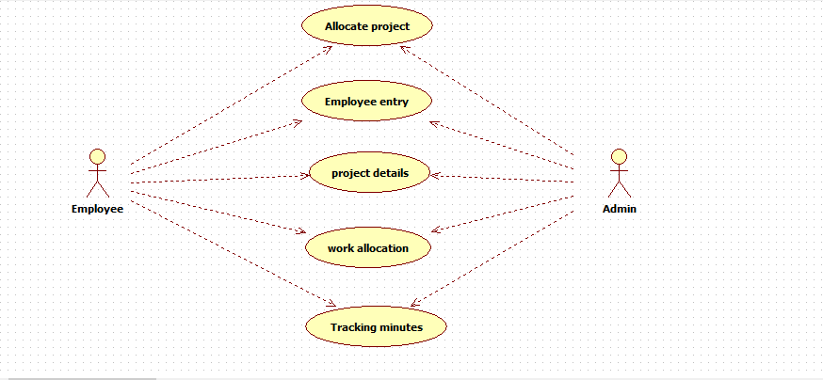

7.1.5 CLASS DIAGRAM

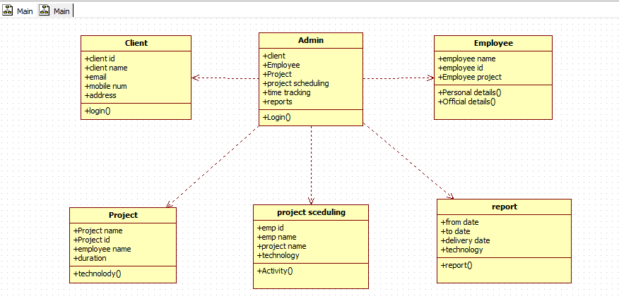

7.1.6 E-R DIAGRAM

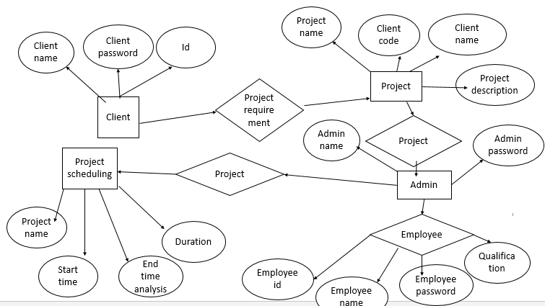

CHAPTER 8
SYSTEM IMPLEMENTATION
8.1 INPUT DESIGN
A project involves the transformation of inputs into an output or product. The task breakdown technique is a very logical approach to identifying the tasks involved in a project. Some people may find it suits them better than using mind maps; other people may find the techniques complement each other. In the Time Tracking application, the admin allocates the project to the employee and
the project scheduling is performed by the admin of the application. The
employee can enter into the web-application with the username, password and they should update the project current daily work status of the project in the web browser.

8.2 OUTPUT DESIGN
The output or outputs might be used within the organisation. The output might be sold as a one-off immediately after the project is complete or used to gain income at some time in the future.
The Time Track application output provides the current status of the project, based on the employee work allocation and the exact scenario of the project under development. The client, project reports can be easily tracked with the reports as the output.

8.3 CODE DESIGN
The main purpose of code design is to simplify the coding and to achieve better performance and quality with free of errors. The employee and the admin are provided with the user name, password details so that the other users can’t able to access the code of the web-application.

8.4 DATABASE DESIGN
The database design involves creation of tables that are represented in physical database as stored files. They have their own existence. Each table constitute of rows and columns where each row can be viewed as record that consists of related information and column can be viewed as field of data of same type. The table is also designed with some position can have a null value. The database design of project is designed in such a way values are kept without redundancy and with normalized format.

CHAPTER 9
SYSTEM TESTING

System testing is a process of checking whether the development system is working according to the original objectives and requirements. The system should be tested experimentally with test data so as to ensure that the system works according to the required specification. When the system is found working, test it with actual data and check performance

Testing Methodologies and policies
Testing is an activity to verify that a correct system is being built and is performed with the intent of finding faults in the system. However not restricted to being performed after the development phase is complete. But this is to carry out in parallel with all stages of system development, starting with requirement specification. Testing results once, gathered and evaluated, provide a qualitative indication of software quality and reliability and serve as a basis for design modification if required a project be set to be incomplete without proper testing.
System testing is a process of checking whether the development system is working according to the original objectives and requirements. The system should be tested experimentally with test data so as to ensure that the system works according to the required specification. When the system is found working, test it with actual data and check performance.

The focus of testing will shift progressively from programs. Exhaustive testing is not possible. To be more effective, testing should be one, which has probability of finding errors.
The Following are the attributes of good test:
A good test has a high probability of finding an error
A good test is not redundant.
A good test should be “Best of Breed”.
Levels of Testing
The details of the software functionality tests are given below. The testing procedures that has been used is as follows
- Unit Testing
- Output Testing
- Performance Testing

9.1 Unit Testing
The first level of testing is called as unit testing. Here the different modules are tested and the specifications produced during design for the modules. Unit testing is essential for verification of the goal and to the test the internal logic of the modules. Unit test was conducted to the different modules of the project. Errors were noted down and corrected down immediately and the program clarity was increased the testing was carried out during the programming stage itself. The modules like Image verification, Text hiding, Image & text processing, Decryption, Text and image extraction etc., were tested.

9.2 Output Testing
The output of the software should be acceptable to the system user. The output requirement is defined during the system analysis. Testing of the software system is done against the output requirements and the output testing was completed with success.

7.3 Performance Testing
This project is a system based project, and the modules are interdependent with the other modules, so the testing cannot be done module by module. So this system is checked only with their performance to check their quality. In case of the unit testing the initialization module is first tested. Since read module and the write module is interdependent the performance testing is done.

CHAPTER 10

CONCLUSION AND FUTURE WORK
In this work, the Time Tracking and Management is proposed based on the web-based application. We believe this is the study to demonstrate the use of textual entailment recognition on project monitoring and control. The experimental results show that the time tracking monitoring and control can effectively evaluate the percentage of progress completion to reduce the human efforts and the costs of the project. However, we find it difficult to further improve the performance of progress completion evaluation of project progress reports under the circumstance of deficient background knowledge. Moreover, our error analysis shows that modifier detection is critical in textual entailment recognition. We speculate that the structured syntactic information may play a critical role in detecting the modifier. This indicates that future success in textual entailment recognition largely depends on effectively exploring structured syntactic information and suggests the urgency in exploring more effective syntactic features for textual entailment recognition in the future. In the future, we will explore more semantic knowledge in textual entailment recognition, which has not been covered deeply by the current research. Meanwhile, we will expand this approach to include more massive projects and even apply it to other applications in Time Tracking and Management.

APPENDIX 1
SOURCE CODE
CLIENT:
<?php require_once("header.php");?>
<body>
<?php require_once("NavBar.php");

if (isset($_REQUEST['submit']))
{

$query="select ifnull(max(Id),10) from Client";
$execute=mysqli_query($conn,$query);
list($id)=mysqli_fetch_array($execute);
$id = $id+1;
$act_id = "CL_".$id;
$flag=0;

$query = "INSERT INTO Client SET Id='".$id."', flag='".$flag."', Client_Id='".$act_id."', Client_Name='".inp('Client_Name')."', Mobile='".inp('Mobile')."', Email='".inp('Email')."', Project_Name='".inp('Project_Name')."', Company_Name='".inp('Company_Name')."', Address='".inp('Address')."',flag_allocate='0'";
if(mysqli_query($conn,$query))
{
echo "<script>alert('Inserted Successfully');window.location='Client.php'</script>";
}
else
{
die("Error : ".mysqli_error($conn));
}
}
$edi=$_REQUEST["Edit"];
if(isset($edi))
{

$qry = mysqli_query($conn,"select * from Client where Client_Id = '".$edi."'");
$res = mysqli_fetch_array($qry);

}

if(isset($_REQUEST["update"]))
{

$sqlt = "update Client SET Mobile='".inp('Mobile')."', Email='".inp('Email')."', Project_Name='".inp('Project_Name')."', Company_Name='".inp('Company_Name')."', Address='".inp('Address')."' where Client_Name='".inp('Client_Name')."'";
if(mysqli_query($conn,$sqlt))
{
header("location:Client.php");

}
else
{
die("Error : ".mysql_error($conn));
}

}

?>
<div class="container-fluid">
<div class="container" id="heading">
<h4>Add Client</h4>
</div>
</div>
<div class="container" id="content">
<form class="form-horizontal" action="<?php echo htmlspecialchars($_SERVER['PHP_SELF'])?>" method="POST" enctype="multipart/form-data">
<div class="form-group">
<label class="control-label col-sm-3">Cient Name: </label>
<div class="col-sm-5">

<input type="text" name="Client_Name" class="form-control" value="<?php echo (isset($_REQUEST['Edit'])) ? $res['Client_Name'] : '' ?>">
</div>
</div>

<div class="form-group">
<label class="control-label col-sm-3">Mobile No.: </label>
<div class="col-sm-5">
<input type="text" name="Mobile" class="form-control" value="<?php echo (isset($_REQUEST['Edit'])) ? $res['Mobile'] : '' ?>">
</div>
</div>

<div class="form-group">
<label class="control-label col-sm-3">Email: </label>
<div class="col-sm-5">
<input type="text" name="Email" class="form-control" value="<?php echo (isset($_REQUEST['Edit'])) ? $res['Email'] : '' ?>">
</div>
</div>

<div class="form-group">
<label class="control-label col-sm-3">Project Name: </label>
<div class="col-sm-5">
<input type="text" name="Project_Name" class="form-control" value="<?php echo (isset($_REQUEST['Edit'])) ? $res['Project_Name'] : '' ?>">
</div>
</div>

<div class="form-group">
<label class="control-label col-sm-3">Company Name: </label>
<div class="col-sm-5">
<input type="text" name="Company_Name" class="form-control" value="<?php echo (isset($_REQUEST['Edit'])) ? $res['Company_Name'] : '' ?>">
</div>
</div>

<div class="form-group">
<label class="control-label col-sm-3">Address : </label>
<div class="col-sm-5">
<textarea name="Address" class="form-control" rows="5"><?php echo (isset($_REQUEST['Edit'])) ? $res['Address'] : '' ?></textarea>
</div>
</div>

<div class="col-sm-2">

<div class="form-group">
<div class="col-sm-offset-5 col-sm-2">
<input type="submit" name="<?php echo (isset($_REQUEST['Edit'])) ? 'update' : 'submit' ?>" value="<?php echo (isset($_REQUEST['Edit'])) ? 'update' : 'Insert' ?>" class="btn btn-primary">
</div>
</div>

</form>
</div>

</body>
</html>

EMPLOYEE ALLOCATION:

<?php require_once("header.php");?>
<body>
<?php require_once("NavBar.php");?>

<div class="container-fluid">
<div class="container" id="heading">

<h4><?php echo 'EMPLOYEE PROJECT ALLOCATION REPORT' ?></h4>
</div>
</div>
<div class="container" id="content">
<form class="form-horizontal" action="<?php echo htmlspecialchars($_SERVER['PHP_SELF'])?>" method="POST" enctype="multipart/form-data">
<div class="form-group">

<?php
$qry="select * from employee";
$exe=mysqli_query($conn,$qry);
?>
<select name="Employee_Name" class="form-controlS">
<option>--Select Employee--</option>
<?php while($fth=mysqli_fetch_array($exe)) {
if ($res['Employee_Name']==$fth['Employee_Name']) {
?>
<option selected><?php echo $res['Employee_Name'] ?></option>

<?php
} else {
?>
<option><?php echo $fth['Employee_Name']; ?></option>

<?php
}
?>
<?php } ?>
</select>

</div>

<div class="col-sm-2">
<input type="submit" name="<?php echo 'Display' ?>" Value="<?php echo 'Display' ?>" class="btn btn-primary">
</div>
</div>
</form>
</div>
<div class="container tblarea">
<table id="table" class="table table-bordered table-hover table-responsive">
<thead>
<tr>
<th>Employee Name</th><th>Project Name</th><th>Technology</th><th>Activity</th><th>Project Status</th>
</tr>
</thead>
<tbody>
<?php
$count = 0;
$Employee_Name=$_POST["Employee_Name"];
$qry = mysqli_query($conn,"select * from project_Schedule where Employee_Name='".$Employee_Name."'");
while($res=mysqli_fetch_array($qry))
{
$count++;
$stat=$res['flag'];
if($stat=='1')
{
$Status="Completed";
}
else
{
$Status="In-Progress Stage";
}
?>
<tr>

<td><?php echo $res['Employee_Name'];?></td>
<td><?php echo $res['Project_Name'];?></td>
<td><?php echo $res['Technology'];?></td>
>
<td><?php echo $res['Activity'];?></td>
<td><?php echo $Status;?></td>

</tr>
<?php }?>
</tbody>
</table>
</div>

</body>

</html>

PROJECT TIME TRACK:

<?php require_once("header.php");?>
<body>
<?php require_once("NavBar.php");?>

<div class="container-fluid">
<div class="container" id="heading">
<h4><?php echo 'CLIENT REPORT' ?></h4>
</div>
</div>
<div class="container" id="content">
<formclass="form-horizontal"action="<?phpecho htmlspecialchars($_SERVER['PHP_SELF'])?>" method="POST" enctype="multipart/form-data">
<div class="form-group">

<?php
$qry="select distinct(Project_Name) from project_Work";
$exe=mysqli_query($conn,$qry);
?>
<select name="Project_Name" class="form-controlS">
<option>--Select Project Name--</option>
<?php while($fth=mysqli_fetch_array($exe)) {
if ($res['Project_Name']==$fth['Project_Name']) {
?>
<option selected><?php echo $res['Project_Name'] ?></option>

<?php
} else {
?>
<option><?php echo $fth['Project_Name']; ?></option>

<?php
}
?>
<?php } ?>
</select>

</div>

<div class="col-sm-2">
<input type="submit" name="<?php echo 'Display' ?>" Value="<?php echo 'Display' ?>" class="btn btn-primary">
</div>
</div>
</form>
</div>
<div class="container tblarea">
<table id="table" class="table table-bordered table-hover table-responsive">
<thead>
<tr>
<th>Project Name </th><th>Technology</th><th>Allocated Duration(Hrs.)</th><th>Time Work Load Taken(Hrs.)</th><th>Project-Status</th><th> Deviation(Hrs.) </th><th>Profit/Loss Info </th>
</tr>
</thead>
<tbody>
<?php
$time_taken=0;
$count = 0;
$Project_Name=$_POST["Project_Name"];
$qry = mysqli_query($conn,"select * from project_Work where Project_Name='".$Project_Name."'");
while($res=mysqli_fetch_array($qry))
{
$count++;
$time_taken=$time_taken + $res['Work_Duration'];
$total_duration=$res['Total_Duration'];

$stat=$res['Project_Status'];
if($stat=='Completed')
{
$Status="Completed";
}
else
{
$Status="In-Progress";
}
}
$deviation=$total_duration-$time_taken;
if($stat=='Completed' and $deviation<0)
{
$project_info="Project in Red Alert...Exceeds the Budget..";
}
else if($stat=='Completed' and $deviation>=0)
{
$project_info="Profit Completed with in Duration..";
$deviation=0;

}
else if($stat=='In-Progress' and $deviation<0)
{
$project_info="Project in Red Alert...Exceeds the Budget...Project In Development Stage";

}
else if($stat=='In-Progress' and $deviation>0)
{
$project_info="Project In Development Stage";

$deviation=0;
}

?>

<?php

$count = 0;
$Project_Name=$_POST["Project_Name"];
if($stat=='Completed')
{
$qry = mysqli_query($conn,"select * from project_Work where Project_Name='".$Project_Name."' and Project_Status='Completed'");
while($res=mysqli_fetch_array($qry))
{
$count++;

$stat=$res['Project_Status'];

?>
<tr>

<td><?php echo $res['Project_Name'];?></td>
<td><?php echo $res['Technology'];?></td>
<td><?php echo $res['Total_Duration'];?></td>
<td><?php echo $time_taken;?></td>

<td><?php echo $Status;?></td>
<td><?php echo $deviation;?></td>
<td><?php echo $project_info;?></td>
</tr>
<?php }

}
else
{
$qry = mysqli_query($conn,"select * from project_Work where Project_Name='".$Project_Name."' and Project_Status='In-Progress'");
$res=mysqli_fetch_array($qry);

$stat=$res['Project_Status'];
?> <tr>

<td><?php echo $res['Project_Name'];?></td>
<td><?php echo $res['Technology'];?></td>
<td><?php echo $res['Total_Duration'];?></td>
<td><?php echo $time_taken;?></td>

<td><?php echo $Status;?></td>
<td><?php echo $deviation;?></td>
<td><?php echo $project_info;?></td>

</tr>
<?php
}

?>
</tbody>
</table>
</div>

</body>

</html>

APPENDIX
SNAPSHOTS

HOME

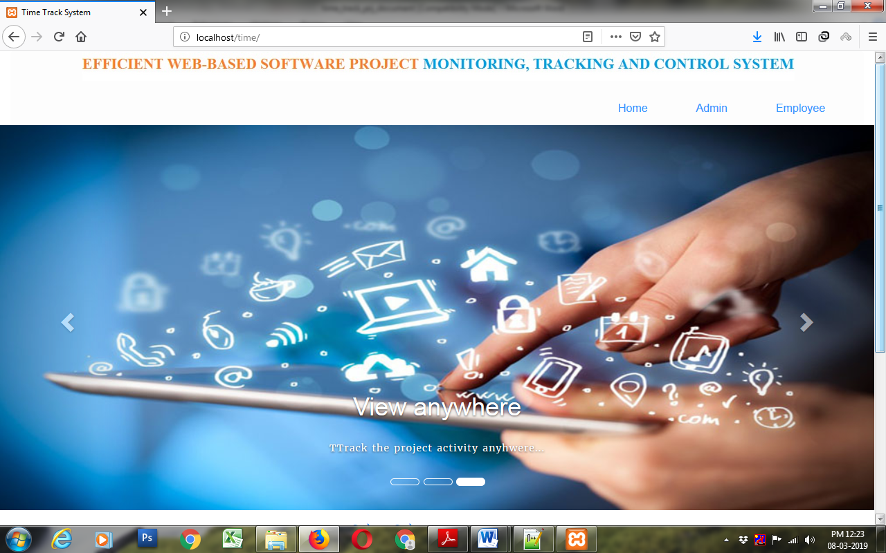

ADMIN

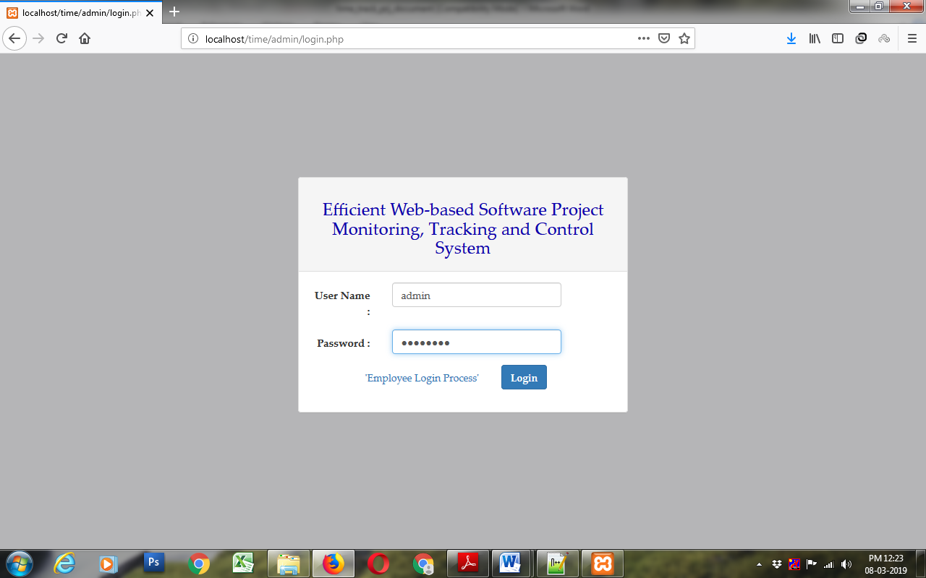

CLIENT

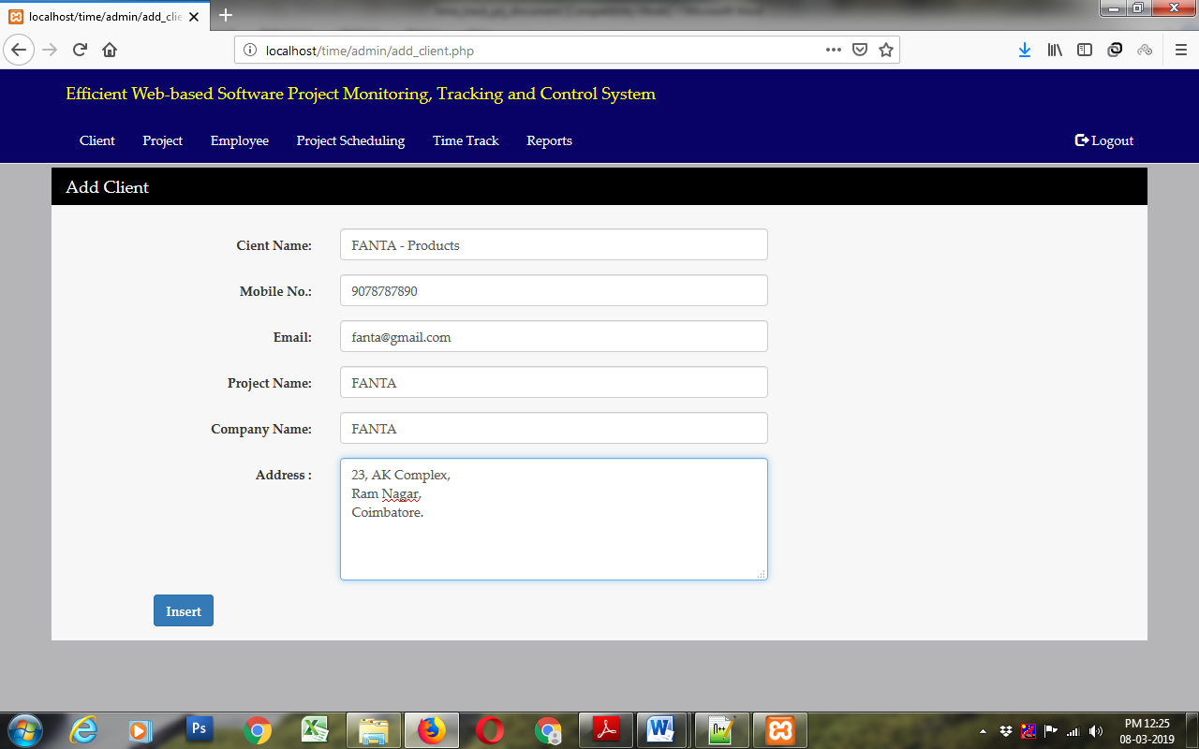

ADD CLIENT

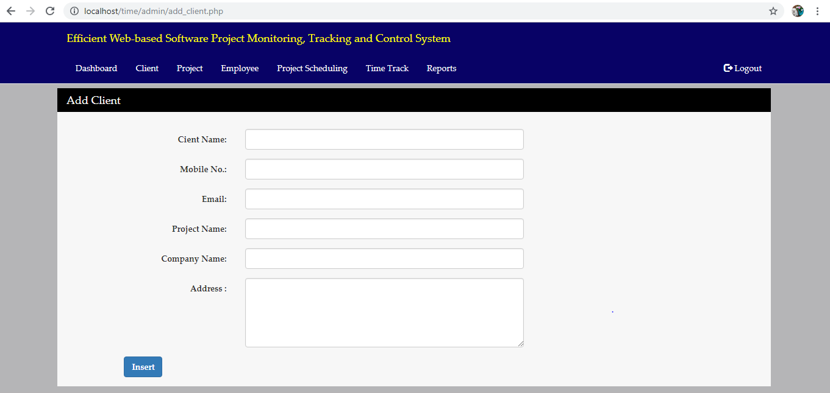

PROJECT

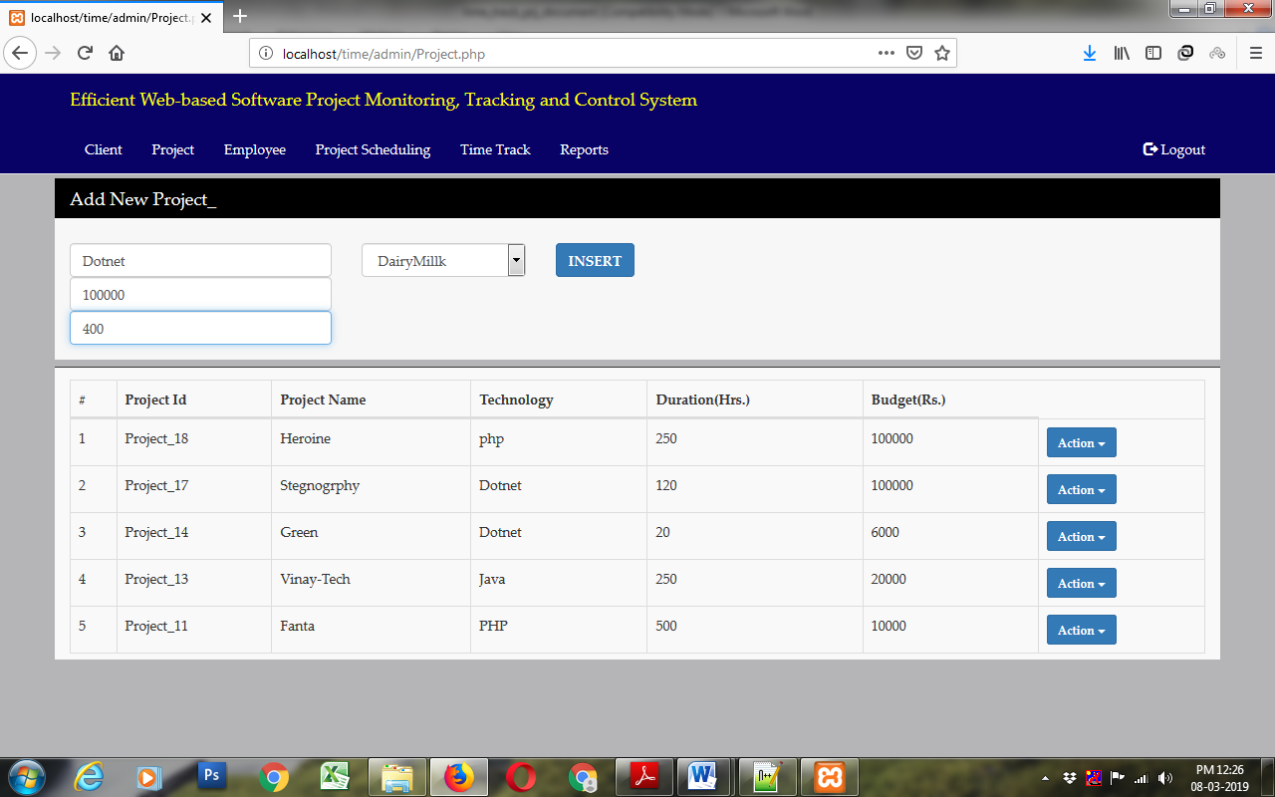

EMPLOYEE

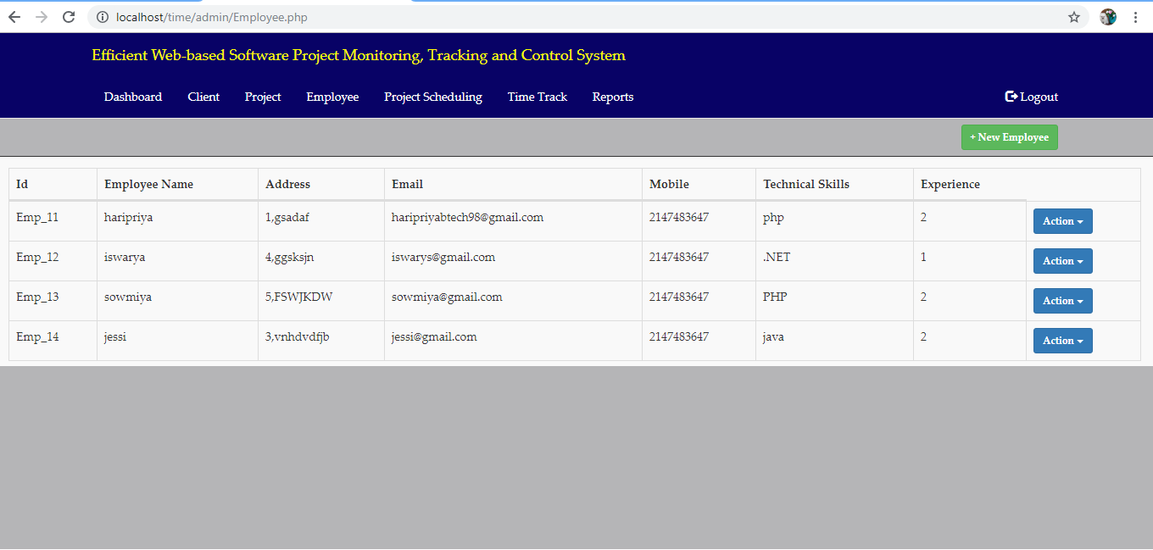

ADD EMPLOYEE

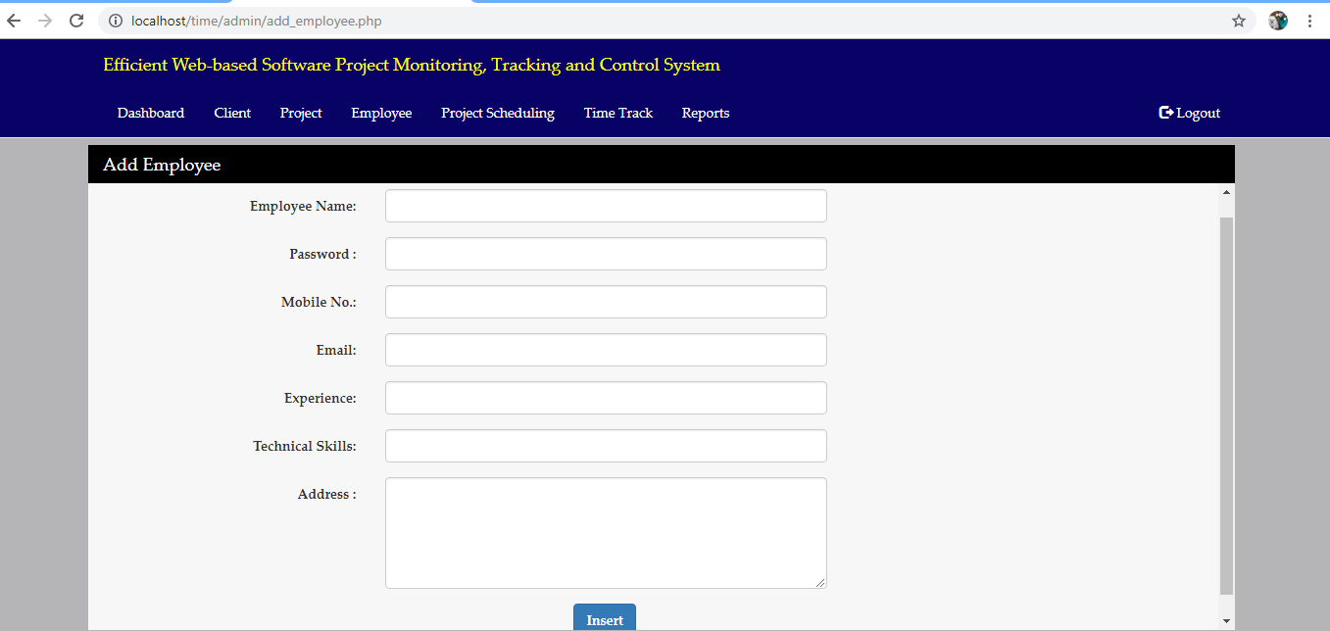

PROJECT ALLOCATION

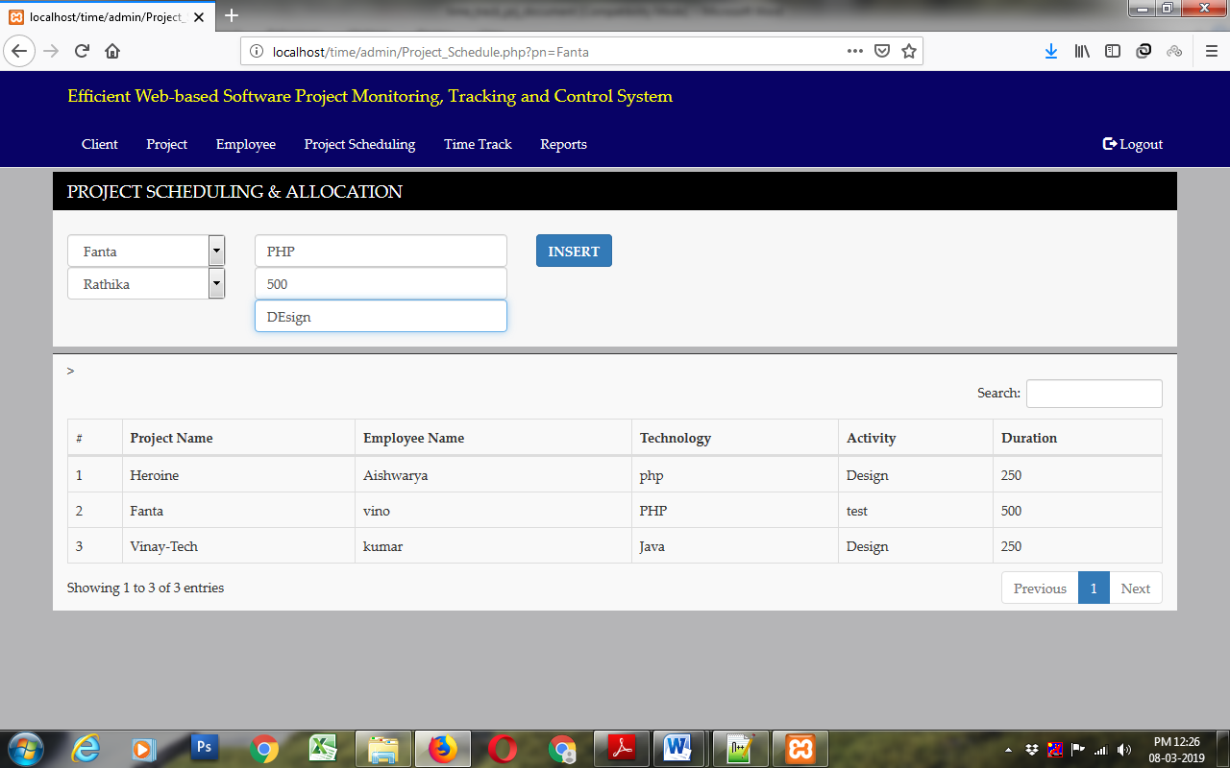

TIME TRACKING

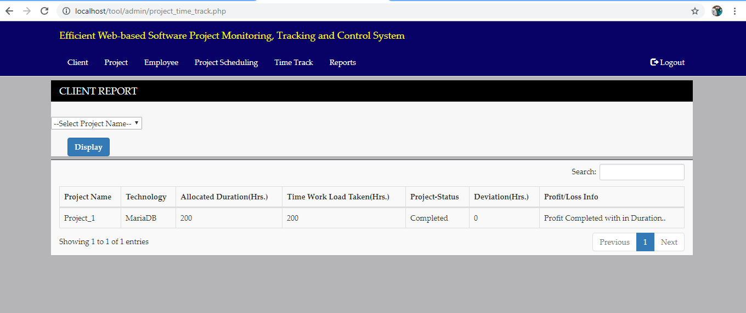

REPORT
CLIENT REPORT
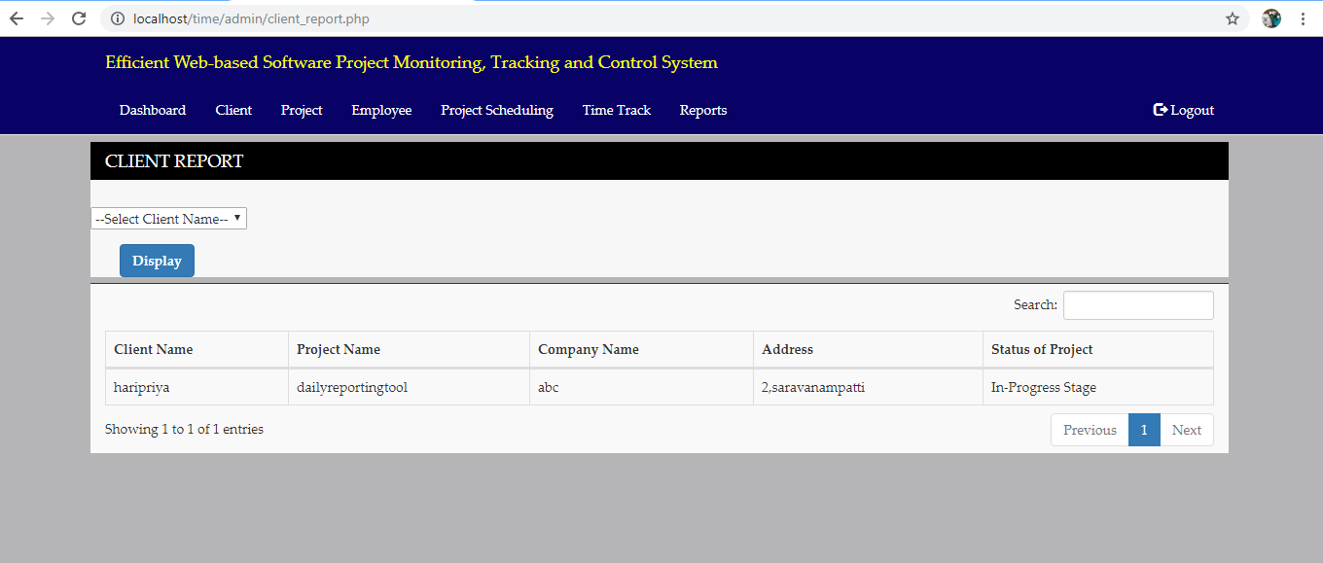

PROJECT REPORT

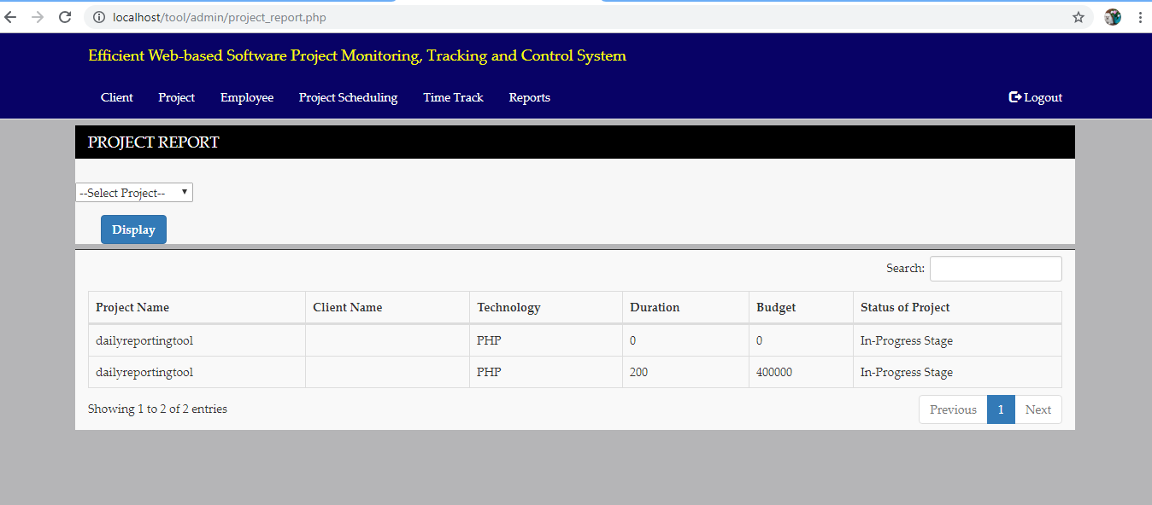

EMPLOYEE REPORT
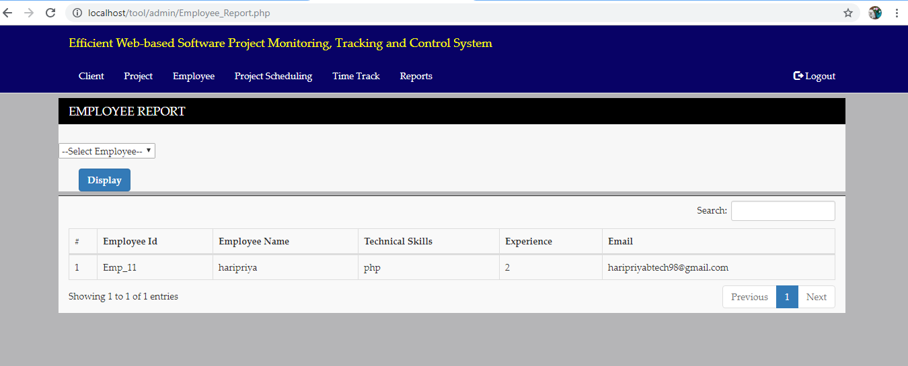

REFERENCES:

[1] A. Gopal and B. R. Koka, “The asymmetric benefits of relational flexibility: Evidence from software development outsourcing,” MIS Quart.,vol. 36, no. 2, pp. 553–576, 2012.
[2] N. Langer, S. A. Slaughter, and T. Mukhopadhyay, “Project Managers’ practical intelligence and project performance in software offshore outsourcing:A field study,” Inform. Syst. Res., vol. 25, no. 2, pp. 364–384, 2014.
[3] M. B. Chrissis, M. Konrad, and S. Shrum, CMMI: Guidelines for Process Integration and Product Improvement. New York, NY, USA: Addison-Wesley, 2011.
[4] S. J. Huang and W. M. Han, “Selection priority of process areas based on CMMI continuous representation,” Inform. Manage., vol. 43, no. 3, pp. 297–307, 2006.
[5] F. Quentin, Cost/Schedule Control Systems Criteria, The Management Guide to C/SCSC. Chicago, IL, USA: Probus, 1998.
[6] W. Lipke, O. Zwikael, K. Henderson, and F. Anbari, “Prediction of project outcome: The application of statistical methods to earned value management and earned schedule performance indexes,” Int. J. Project Manage., vol. 27, pp. 400–407, 2009.
[7] W. Lipke, “Schedule is different,” Meas. News, pp. 31–35, 2003. [8] R. Jack and S. Meredith Mantel Jr., Project Management: A Managerial Approach. New York, NY, USA: Wiley, 2011.
[9] R. Sacks, R. Navon, I. Brodetskaia, and A. Shapira, “Feasibility of automated monitoring of lifting equipment in support of project control,” J. Construction Eng. Manage., vol. 131, no. 5, pp. 604–614, 2005.
[10] R. Conforti, M. Rosa, G. Fortino, A. H. M. Hofstede, J. Recker, and M. Adams, “Real-time risk monitoring in business processes: A sensorbased approach,” J. Syst. Softw., vol. 86, no. 11, pp. 2939–2965, 2013.
[11] K. J. Chen, S. L. Huang, Y. Y. Shih, and Y. J. Chen, “Extended-hownet a representational framework for concepts,” in Proc. 2nd Int. Joint Conf. Natural Language Process., 2005, pp. 1–6.
[12] S. Kim, C. Park, S. Lee, and J. Son, “Integrated cost and schedule control in the Korean construction industry based on a modified work-packaging model,” Can. J. Civil Eng., vol. 35, no. 3, pp. 225–235, 2008.
[13] I. Dagan, O. Glickman, and B. Magnini, “The Pascal recognising textual entailment challenge,” Mach. Learning Challenges, vol. 3944, pp. 177– 190, 2006.
[14] S. Harabagiu and A. Hickl, “Methods for using textual entailment in opendomain
question answering,” in Proc. 21st Int. Conf. Comput. Linguistics 44th Annu. Meeting, 2006, pp. 905–912.
[15] D. Tatar, E. T. Morita, A. Mihis, and D. Lupsa, “Summarization by logic segmentation and text entailment,” in Proc. Conf. Intell. Text Process. Comput. Linguistics, 2008, pp. 15–26.
[16] S. Harmeling, “An extensible probabilistic transformation-based approach to the third recognizing textual entailment challenge,” in Proc. ACLPASCAL Workshop Textual Entailment Paraphrasing, 2007, pp. 137–142.
[17] D. Lin and P. Pantel, “Discovery of inference rules for question answering,” Natural Language Eng., vol. 7, no. 4, pp. 343–360, 2001.
[18] I. Szpektor and I. Dagan, “Learning entailment rules for unary templates,” in Proc. 22nd Int. Conf. Comput. Linguistics, 2008, pp. 849–856.
[19] C. Brockett and W. B. Dolan, “Support vector machines for para-phrase identification and corpus construction,” in Proc. 3rd Int. Workshop Paraphrasing, 2005, pp. 1–8.
[20] P. Malakasiotis, “Aueb at tac 2009,” in Proc. TAC 2009 Workshop Textual Entailment.

